Dear Colleagues,
Below is an initial snapshot of media coverage of the Heart-2 study results. Overall, media viewed the results as promising early evidence that a single treatment with VERVE-102 may deliver lasting cholesterol reduction.
A full pulse report on media and digital coverage will follow later this week. Paywalled full text articles are attached.
Coverage Takeaways
- Coverage was high-volume and global: 1,339 news and digital articles across 55 countries during 2026-05-25 to 2026-05-31, led by the United States, India and China.
- Sentiment was neutral-to-positive — 55% positive and 45% neutral, with no negative coverage — signaling that media treated the results as credible, encouraging early-stage data rather than overstated.
- Coverage centered on the one-time, durable nature of the treatment and the PCSK9 gene-editing mechanism, with the New York Times framing it as “One-and-Done Heart Disease Prevention.”
Key Message Pull Through
[DRAFT — provisional key messages from the EAS example, matched on article snippets only. Replace with the official message list + keywords and run on full-text articles for accurate pull-through.]
- 33% Results showed encouraging evidence for VERVE-102 to be a one-time treatment
- 51% VERVE-102 is designed to durably turn off the PCSK9 gene
- 1% Lilly plans to begin enrolling the Phase 2 clinical study
- 0% VERVE-102 is designed to mimic the protective effect of naturally occurring loss-of-function variants in PCSK9
Sentiment Analysis
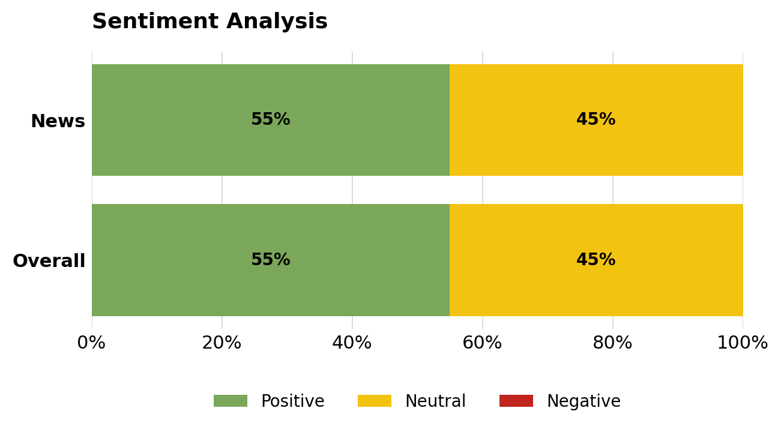
Type of Coverage by Reach
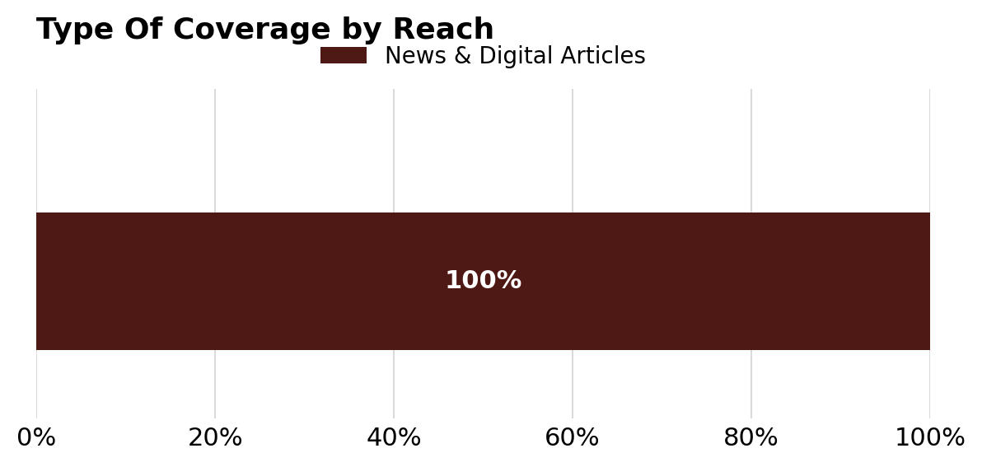
[Social Media and Podcast segments will populate once the full export (with social/podcast rows) is provided.]
Top News
The coverage below reflects a snapshot of the highest-impact publications within each media tier based on reach; it is not exhaustive.
Top Tier (US, by reach)
- The New York Times: One-and-Done Heart Disease Prevention? Scientists Show It May Be Possible.
- MSN.com: A single shot just slashed dangerous cholesterol levels for a full year in a late-stage trial — a gene-silencing therapy built to replace the daily statins millions take
- Substack: One Infusion. A Permanent Gene Edit. A Lifetime of LDL Lowering. The VERVE-102 NEJM Data, the Lilly Acquisition Thesis, and What It Means.
- Yahoo! News: New drug to treat high cholesterol could be 1-time therapy
- Chase: A single dose of Lilly's PCSK9 base editor, VERVE-102, reduced PCSK9 by up to 88% and LDL-C by up to 62%, with durable effects supporting its potential as a one-time treatment for hypercholesterolemia
OUS / Global Media
- Naver: 1회 투여로 심장질환 장기예방?…유전자편집약물 소규모시험 효과
- NDTV.com: New One-Shot Gene Editing Therapy May Reduce Bad Cholesterol By 62%
- News18: क्या होती है जीन थेरेपी, जिससे बैड कोलेस्ट्रॉल किए जा सकते हैं बाहर?
- 163.com: 一款国产口服减重药进入临床三期；礼来13亿美元买来的降脂药，公布1期临床结果｜掘金创新药
- UOL Jogos: Tratamento experimental com dose única reduz colesterol em 62%
[Tiers are auto-ordered by reach for this draft. Final report applies the editorial tier rubric — Top Tier, Investor Influence, Industry/Trade & Policy, General Population, OUS/Global.]

